Ideation Phase

Define the Problem Statements

|  |  |
| --- | --- |
| Date | 18 June 2025 |
| Team ID | **LTVIP2025TMID37723** |
| Project Name | Pattern sense: classifying fabric patterns using  deep learning |
| Maximum Marks | 2 Marks |

Customer Problem Statement Template:

I am **a textile manufacturer, fashion designer, or fabric retailer** who works with a large variety of fabric patterns.

I’m trying to efficiently and accurately classify fabric patterns into different design categories (such as floral, geometric, abstract, etc.) in order to automate inventory management, support design selection, and improve customer recommendations.

But the current manual process of inspecting and categorizing fabric patterns is slow, subjective, and requires skilled labor, leading to errors and inconsistencies.

Because there is no intelligent, automated system that can accurately recognize and classify fabric patterns from images at scale using advanced AI and deep learning methods.

Which makes me feel frustrated by inefficiency, limited in scaling operations, and unable to deliver personalized and modern experiences to customers.

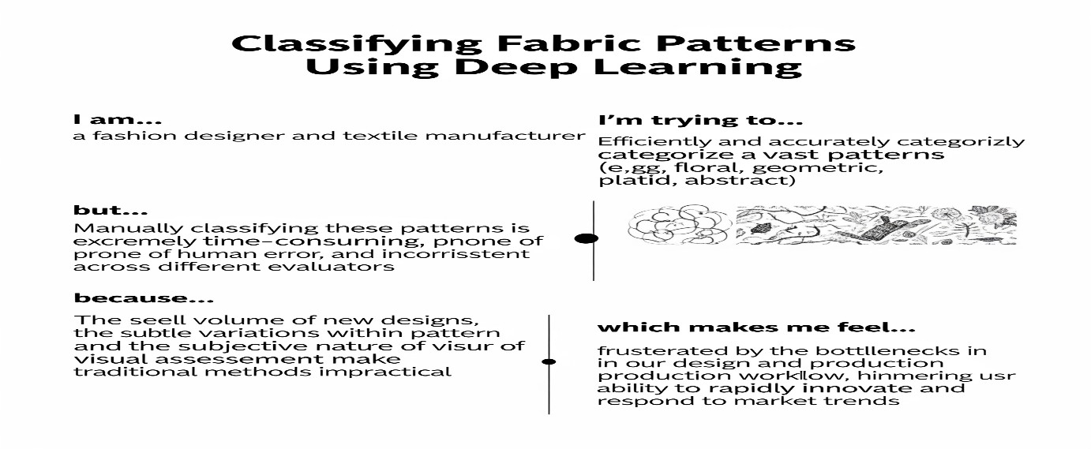

Problem Statement (PS)

I am I’m trying to But Because (Customer)

Which makes me feel

PS-1 A textile manufacturer

Automate the classification of

Manual classification is

There is no AI- based system

Frustrated, limited in

Problem Statement (PS)

I am I’m trying to But Because (Customer)

Which makes me feel

PS-2

A fashion retailer or designer

fabric patterns to improve inventory and production efficiency

Recommend designs to customers based on their pattern preferences

slow and inconsistent

Current methods lack precise, automated pattern categorization

capable of accurately recognizing and classifying complex fabric patterns

There is no advanced deep learning solution to identify pattern types reliably

scalability, and inefficient

Unable to provide personalized experiences and competitive service